Human Activity Recognition on Shimmer Accelerometer Data:

Classical ML Evaluation
Oct 15, 2026 · Khelif Hadil
CDTA internship, ML Fundamentals & Transfer Learning ·
Supervisor: Dr. Oussama Kerdjidj

1. Summary
This report documents the classical machine-learning stage of the internship: classifying seven activities (Fall, Jump, Lay, Run, Sit, Stand, Walk) from Shimmer accelerometer recordings.
- Data: 245,760 samples cut into 1,920 non-overlapping windows of 128 samples, each described by 12 features (max, min, mean, standard deviation of X, Y and Z).
- Protocol: KNN, SVM and Decision Tree, tuned by nested grid search, evaluated over 10 repeated random splits with MCC and a p-value. Tuned KNN is best (accuracy 0.962, MCC 0.955).
- Control added: a segment-grouped split that keeps every recording segment entirely in train or in test. Scores drop to 0.74–0.78 balanced accuracy, SVM becomes the best model, and the differences between models are no longer statistically significant after correction.
- Main weakness: Sit and Stand are confused with each other as soon as the segments are unseen.
- Against chance: all three models are far above chance (permutation test, p = 0.0099, the smallest value possible with 100 permutations).
Status against the assignment
Assignment item | Status
Data preparation and exploration (loading, cleaning, plots, features) | Done
Plot each class for 1,000 samples | Done
Features max, min, mean, std for X, Y, Z on 128-sample windows | Done
three algorithms with hyperparameter optimization (KNN, SVM, Decision Tree) | Done
Run at least 10 times with random splits, we can run more, report MCC | Done
p-value | Done
Accuracy, precision, recall, F1 and ROC-AUC | Done
Transfer learning (VGG or ResNet) | Not started
Documentation | This report &the project README

2. Data
The dataset has seven MATLAB files, one per activity, each holding an 11-column matrix: column 0 is the timestamp, columns 1–3 are acceleration X, Y, Z, and the remaining seven channels are not used yet.
Activity | Samples | Windows | Segments
Fall | 6,016 | 47 | 13
Jump | 18,304 | 143 | 12
Lay | 42,240 | 330 | 12
Run | 36,992 | 289 | 13
Sit | 44,032 | 344 | 10
Stand | 52,480 | 410 | 16
Walk | 45,696 | 357 | 13
Total | 245,760 | 1,920 | 89
The classes are imbalanced (Fall has 47 windows, Stand 410), which is why balanced accuracy and MCC are reported next to accuracy.
Three properties of the recordings shape the evaluation:
- Sampling rate. The median timestamp step is 19.53 units, which gives about 51.2 Hz if the unit is milliseconds. A 128-sample window then lasts about 2.50 s; . The window size stays at 128 samples.
- Concatenated recordings. Timestamps are not monotonic (87 non-positive steps across the files). Most discontinuities fall exactly on multiples of 128 samples, so each file looks like several recording segments stitched together. A segment is started at every timestamp reset, which gives 89 segments, 10 to 16 per class. Only one 128-sample window crosses a reset.
- No subject or session identifiers. Each activity is a single file, so the segments are the only available proxy for independent recordings.

3. Method

3.1 Windowing and features
Each file is cut into complete, non-overlapping windows of 128 samples; there is no leftover because every file length is a multiple of 128. For each axis the features are the maximum, minimum, mean and sample standard deviation, which gives 12 features per window.

3.2 Models and tuning
Standardization is fitted on the training data inside each pipeline. Hyperparameters are chosen by grid search with 5-fold stratified cross-validation on the training split only, scored by balanced accuracy; the test split is used once

Model | Search grid
KNN | k in {3, 5, 7, 9, 11}, uniform or distance weights, Manhattan or Euclidean distance
SVM | RBF with C in {0.1, 1, 10} and gamma in {scale, 0.01, 0.1}; linear with C in {0.1, 1, 10}
Decision Tree | Gini or entropy, max depth in {none, 5, 10, 20}, min samples split in {2, 5, 10}, min samples leaf in {1, 2, 4}

3.3 Two evaluation protocols
- A. Random window split.
- B. Segment-grouped split (control). each randomly assigning whole segments of every class to train or test, so that no segment contributes to both. The test part holds roughly 30–35% of the windows because whole segments are drawn. The tuning cross-validation is grouped in the same way.
NOTE: Why protocol B was added. Each activity is stored in one file made of several recording segments (89 in total, split at timestamp resets), and windows from the same segment are almost identical. With a random window split (protocol A), a test window often has a near-twin in the training set, so the model can score well by recognizing the segment instead of the activity. This is data leakage and it inflates the scores. Protocol B keeps each whole segment in either train or test, including in the tuning cross-validation, so the test segments are truly unseen. It confirms the leakage: balanced accuracy falls from 0.93 to 0.74 for KNN, from 0.92 to 0.76 for the Decision Tree and from 0.89 to 0.78 for the SVM.

3.4 Metrics and statistical tests
Metrics: accuracy, balanced accuracy, weighted and macro F1, MCC (Matthews correlation coefficient) and macro one-vs-rest ROC-AUC.
Tests: a permutation test against chance level (100 label shuffles, 5-fold, balanced accuracy); paired comparisons between models over the 10 runs with the Wilcoxon signed-rank test and the Nadeau–Bengio corrected resampled t-test, both Holm-adjusted for the three pairs; and a Friedman test over the three models. The runs reuse the same windows, so they are not independent and all p-values are approximate.

4. Results

4.1 Mean over 10 runs (± standard deviation)
Protocol | Model | Accuracy | Macro F1 | MCC | ROC-AUC
A. Random | KNN | 0.962 ± 0.009 | 0.943 | 0.955 ± 0.011 | 0.983
A. Random | Decision Tree | 0.930 ± 0.014 | 0.915 | 0.916 ± 0.017 | 0.959
A. Random | SVM | 0.884 ± 0.009 | 0.896 | 0.861 ± 0.010 | 0.974
B. Grouped | SVM | 0.779 ± 0.061 | 0.756 | 0.742 ± 0.075 | 0.935
B. Grouped | Decision Tree | 0.759 ± 0.072 | 0.730 | 0.723 ± 0.086 | 0.898
B. Grouped | KNN | 0.747 ± 0.056 | 0.725 | 0.702 ± 0.069 | 0.880
.

4.3 Recall per class
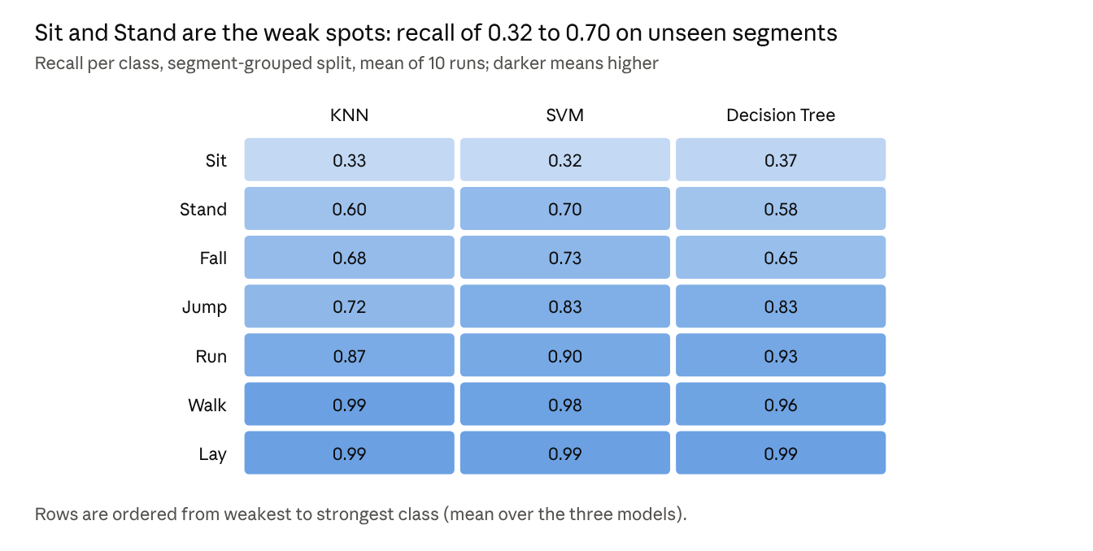

4.4 Statistical tests
Against chance. With 100 permutations the smallest possible p-value is 1/101 = 0.0099, and all three models reach it. The shuffled-label balanced accuracy averages about 0.14 (1/7) and never exceeds 0.20, against 0.90–0.94 for the real labels.
Between models (balanced accuracy, Holm-adjusted p-values):
Protocol | Pair | Wilcoxon | Corrected t-test
A. Random | KNN vs SVM | 0.006 | 0.012
A. Random | KNN vs Decision Tree | 0.010 | 0.157
A. Random | Decision Tree vs SVM | 0.006 | 0.062
B. Grouped | KNN vs SVM | 0.012 | 0.344
B. Grouped | Decision Tree vs SVM | 0.168 | 0.788
B. Grouped | KNN vs Decision Tree | 0.275 | 0.788
The Friedman test gives p = 0.0001 for protocol A and p = 0.045 for protocol B.
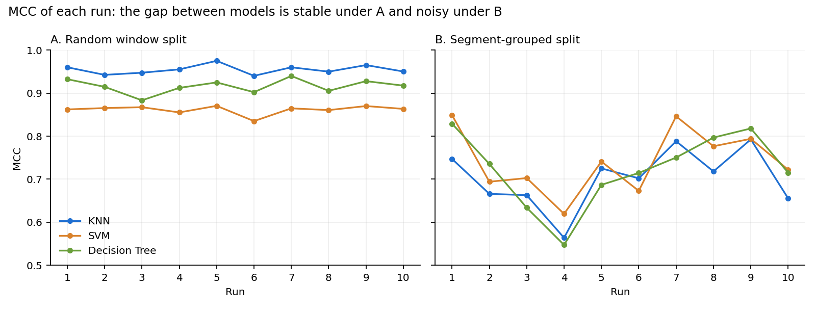
MCC of every run. Under protocol A, KNN has the highest MCC in all 10 runs. Under protocol B it is never first: SVM leads in 6 runs and the Decision Tree in 4, which is why no pairwise difference is significant.

5. Discussion
Random splits overestimate performance. Neighboring windows from the same segment are almost identical, so a random split lets the model recognize the segment instead of the activity. KNN profits most, especially with k = 3 and distance weighting, and drops from 0.93 to 0.74 balanced accuracy once segments are separated.
The model ranking is not stable. Under protocol A, KNN beats SVM with a clear margin (corrected t-test p = 0.012). Under protocol B the order reverses, and no pairwise difference survives the corrected test (p ≥ 0.34). With the current data the honest conclusion is that the three models are comparable on unseen segments, with a slight edge for SVM.

6. Limitations
- The segments come from timestamp resets and are not verified recording or participant identifiers; protocol B is a reasonable control, not proof of generalization to new subjects.
- Runs overlap, so the p-values are approximate and ten runs give limited resolution.
- The permutation test uses models tuned on all windows, which is slightly optimistic, and it is computed for protocol A only.
- Timestamp units, the column mapping and the sampling frequency are not confirmed.
- The Fall class is small, so its recall is uncertain.

7. Next steps
- Transfer learning, the second step of the assignment: turn the acceleration magnitude into an image (for example a CWT scalogram or a Gramian angular field), load a pre-trained VGG or ResNet, freeze the early layers and retrain the classifier head, then evaluate it with the same two protocols, metrics and tests.
- Richer features (RMS, median, skewness, kurtosis, signal magnitude, frequency-domain energy) as a controlled comparison, mainly to separate Sit from Stand.

8. Streamlit dashboard
The dashboard (app.py) runs the whole pipeline: loading, data quality, signals, experiments, model comparison and downloads.
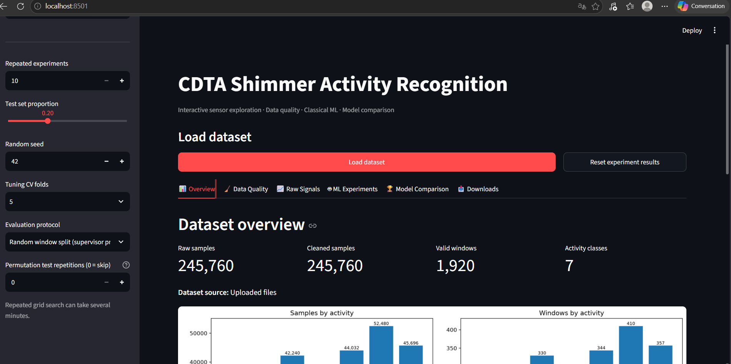
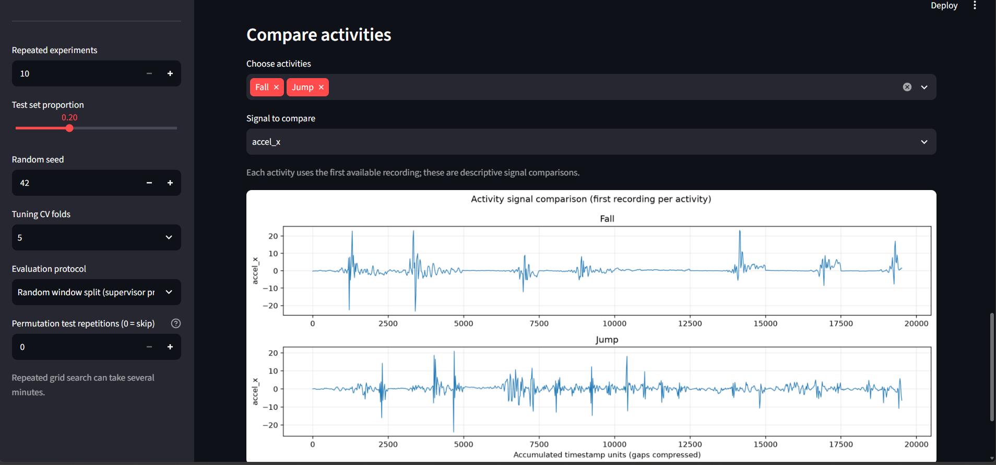
Raw Signals tab
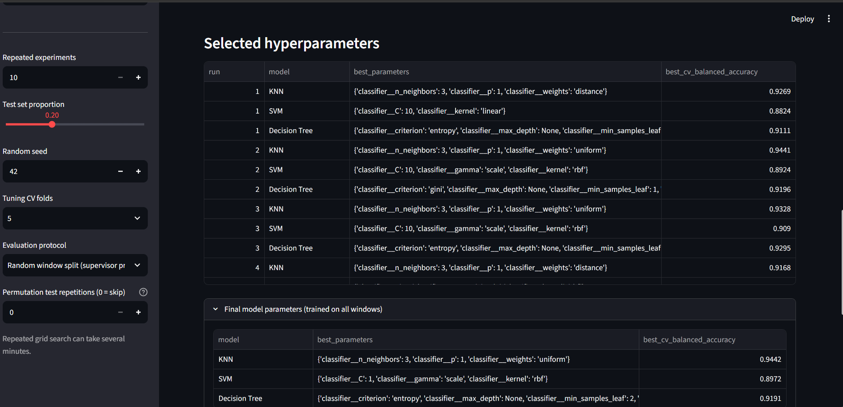
ML Experiments tab
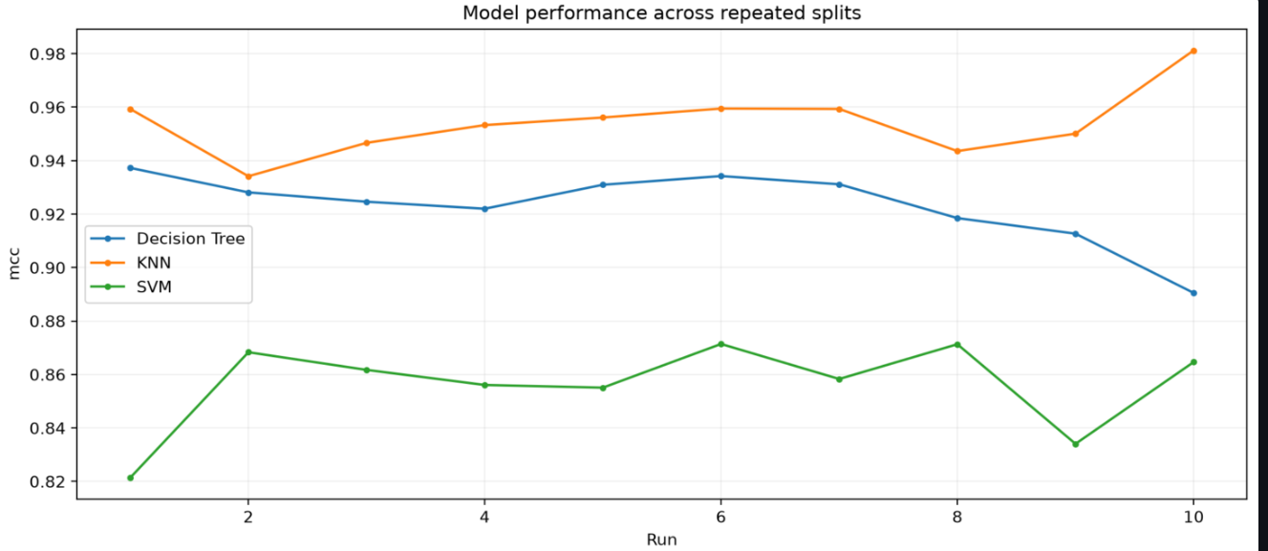
Model Comparison tab: 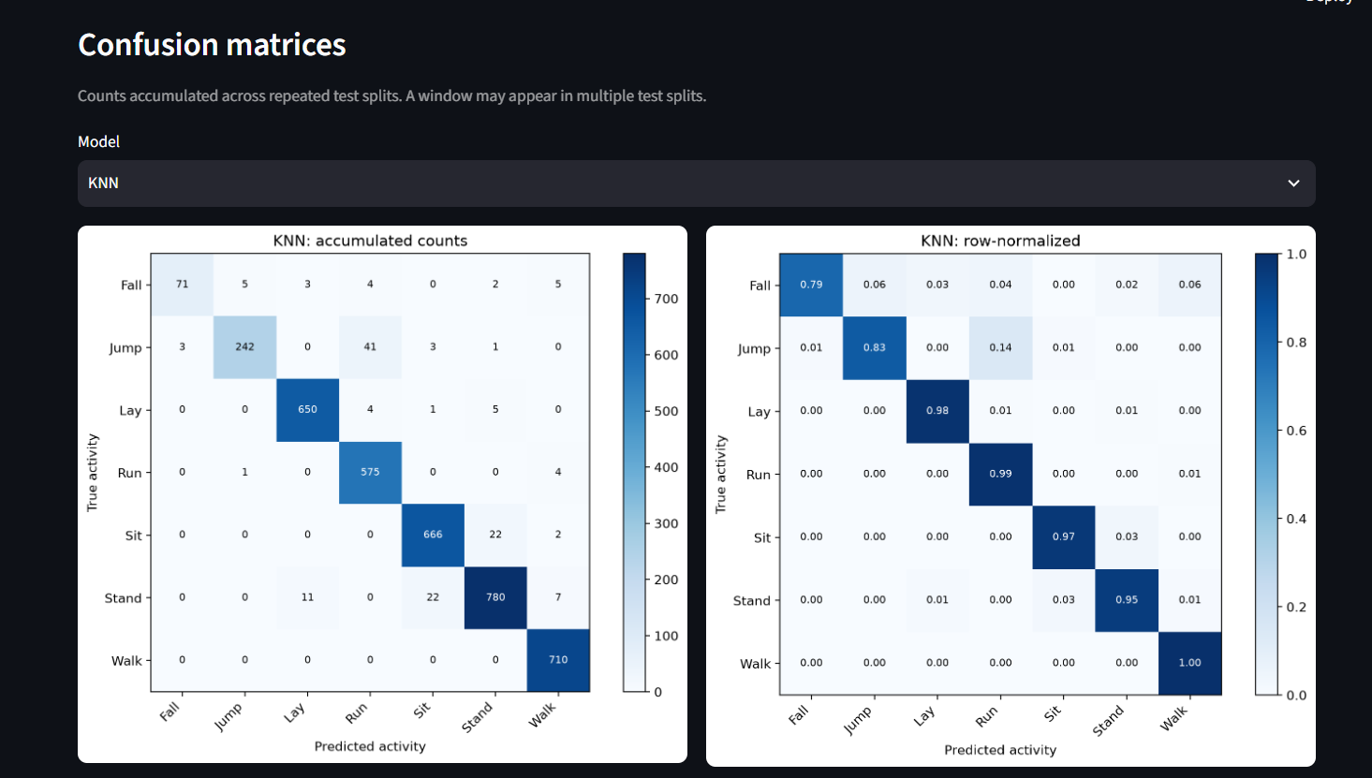
Model Comparison tab
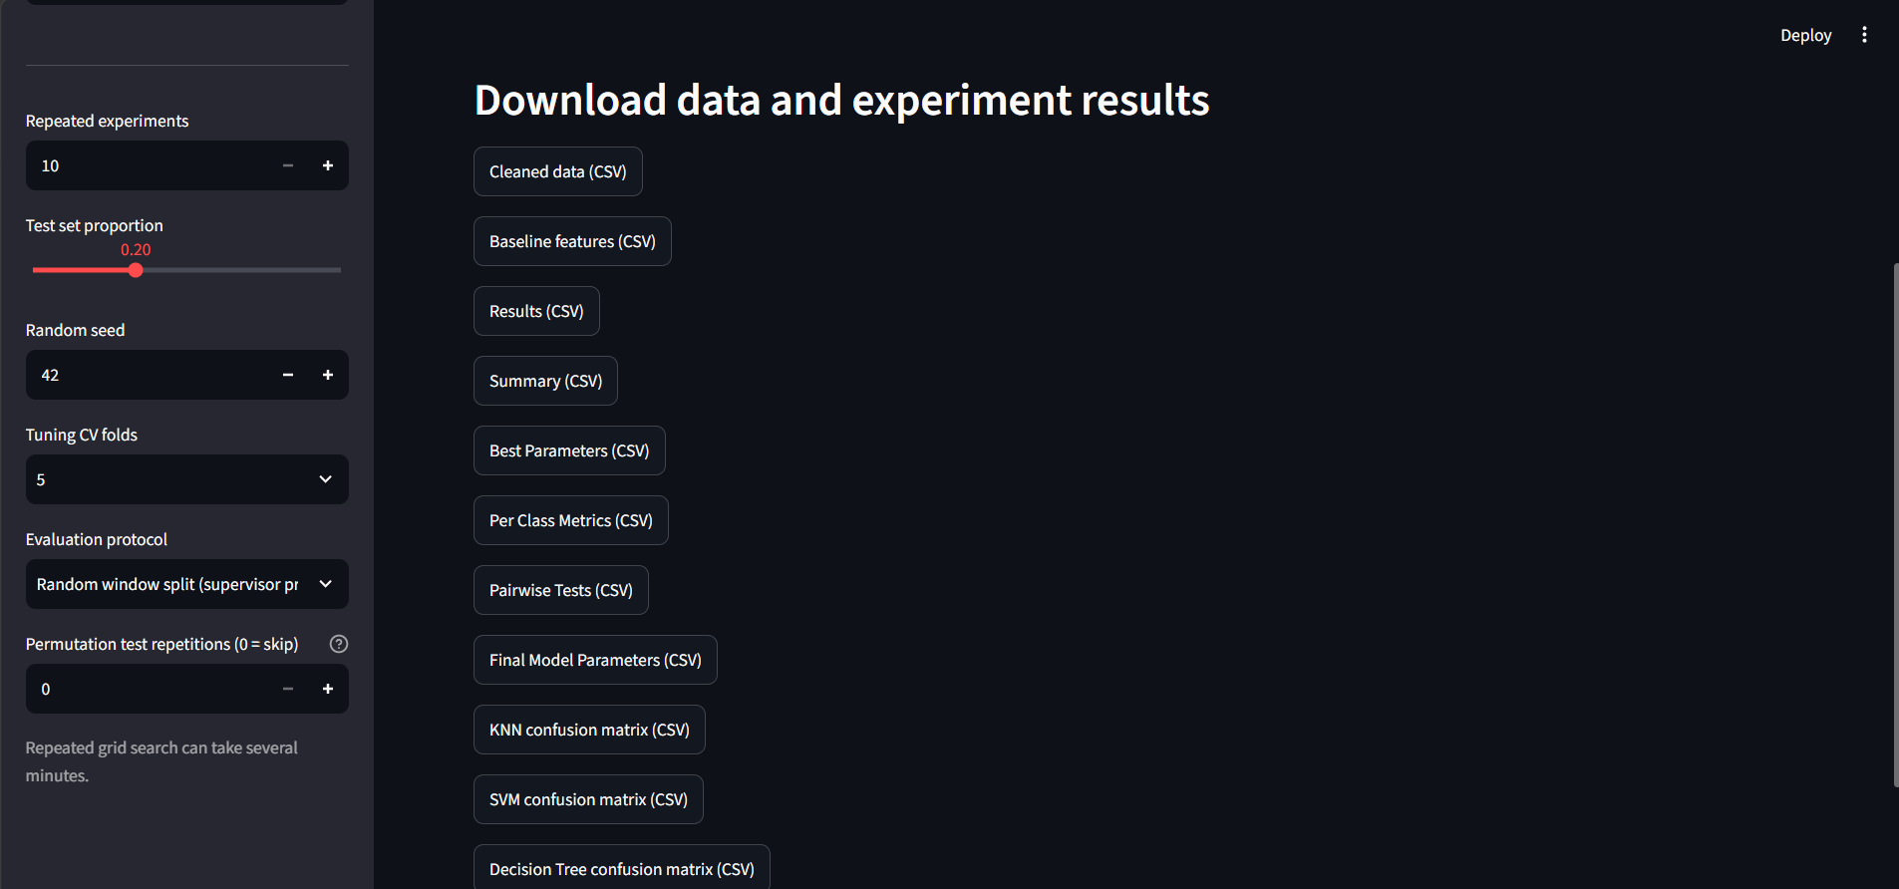
Downloads tab

9. Reproducibility
The code is a Python 3 project (NumPy, pandas, SciPy, scikit-learn, Matplotlib, Streamlit): data_utils.py loads and cleans the files, feature_extraction.py builds the windows and group_id, ml_experiments.py runs the experiments, stat_tests.py computes the p-values and app.py is the Streamlit dashboard. The seed is 42 and run r uses seed 42 + r. See the README for the commands.

10. Work performed
- Leakage check. Because each class is one file made of stitched segments, a random window split can place near-identical neighboring windows in train and test. A quick KNN check gave about 95% accuracy with a random split and about 75% with a temporal block split, which motivated the segment-grouped protocol.
- Implementation: a segment identifier (group_id) from the timestamp resets, the segment-grouped protocol (outer split and tuning folds), macro one-vs-rest ROC-AUC, the permutation test against chance, paired tests between models (Wilcoxon, corrected t-test, Holm, Friedman)

11.complete metrics
Mean ± standard deviation over 10 runs. Weighted precision, recall and F1 weight each class by its number of windows; macro F1 weights classes equally.
Protocol A, random window split
Model | Accuracy | Balanced acc. | Weighted precision | Weighted recall | Weighted F1 | Macro F1 | MCC | ROC-AUC | Tuning + fit (s)
KNN | 0.962 ± 0.009 | 0.930 ± 0.024 | 0.963 | 0.962 | 0.961 | 0.943 ± 0.018 | 0.955 ± 0.011 | 0.983 ± 0.006 | 1.2
Decision Tree | 0.930 ± 0.014 | 0.917 ± 0.019 | 0.931 | 0.930 | 0.930 | 0.915 ± 0.016 | 0.916 ± 0.016 | 0.959 ± 0.012 | 6.1
SVM | 0.884 ± 0.009 | 0.894 ± 0.017 | 0.886 | 0.884 | 0.882 | 0.895 ± 0.013 | 0.861 ± 0.010 | 0.974 ± 0.006 | 2.2
Protocol B, segment-grouped split
Model | Accuracy | Balanced acc. | Weighted precision | Weighted recall | Weighted F1 | Macro F1 | MCC | ROC-AUC | Tuning + fit (s)
SVM | 0.779 ± 0.061 | 0.780 ± 0.051 | 0.778 | 0.779 | 0.764 | 0.756 ± 0.050 | 0.742 ± 0.075 | 0.935 ± 0.026 | 1.9
Decision Tree | 0.759 ± 0.072 | 0.757 ± 0.053 | 0.771 | 0.759 | 0.743 | 0.730 ± 0.061 | 0.723 ± 0.086 | 0.898 ± 0.044 | 5.6
KNN | 0.747 ± 0.056 | 0.741 ± 0.050 | 0.757 | 0.747 | 0.735 | 0.725 ± 0.050 | 0.702 ± 0.069 | 0.880 ± 0.034 | 1.2
Most frequently selected configuration per run
Protocol | KNN | SVM | Decision Tree
A. Random | k = 3, Manhattan (p = 1), distance weights (4 of 10 runs) | RBF, C = 10, gamma = scale (8 of 10) | entropy, unlimited depth, min samples split 10 (5 of 10)
B. Grouped | k = 3, Manhattan, distance weights (3 of 10) | RBF, C = 10, gamma = scale (5 of 10) | no majority (entropy, depth 5, min leaf 4 in 2 of 10)

